**Logical reasoning Test (set 2)**

**Company name: Deloitte No. of Question: 25**

**1:**

In the following question, select the number which can be placed at the sign of question mark (?) from the given alternatives.

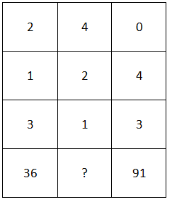

1. 85
2. 73
3. 67
4. 92

**Answer:** option b

**Solution:**

Clearly, (1st row )3 + (2nd row)3 + (3rd row)3 = 4th row.

So, In the first column, 23 + 13 + 33 = 8 + 1 + 27 = 36

In the third column, 03 + 43 + 33 = 0 + 64 + 27 = 91

In the second column, missing number = 43 + 23 + 13 = 64 + 8 + 1 = 73

So, missing number = 73

**2:**

If P means ‘÷’, R means ‘×’, T means ‘+’ and W means ‘-' then

60 T 48 P 8 W 6 R 9 = ?

1. 12
2. 34
3. -40
4. 243

**Answer:** option a

**Solution:**

The given expression is

60 T 48 P 8 W 6 R 9

↓ ↓ ↓ ↓

60 + 48 ÷ 8 – 6 × 9

Using BODMAS RULE, we get

60 + 48 ÷ 8 – 6 × 9 = 60 + 6 – 54 = 66 – 54 = 12

Therefore, the value of the given expression = 12

**3:**

Which of the following figure can make by using given figure?

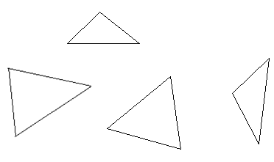

1. 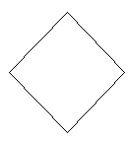
2. 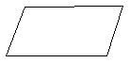
3. 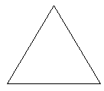
4. 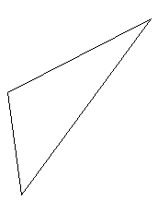

**Answer:** option c

**Solution:**

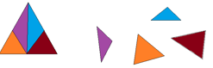

**4:**

Select a figure amongst the four alternatives, which when placed in the blank space of figure (X) would complete the pattern.

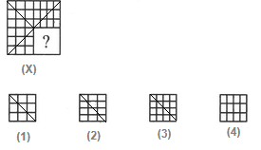

1. (1)
2. (2)
3. (3)
4. (4)

**Answer:** option d

**Solution:**

Figure in option 4 indicates the figure required to complete the question figure.

**5:**

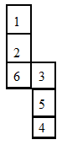

Which of the following is the opposite side of 1 in given dice?

1. 2
2. 6
3. 3
4. 4

**Answer:** option b

**Solution:**

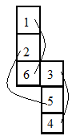

1 opposite number 6

2 opposite number 5

3 opposite number 4

**6:**

F's father is the son-in-law of the husband of G's mother. How is G's father related to F?

1. Father
2. Maternal grandfather
3. Son
4. Uncle

**Answer:** option b

**Solution:**

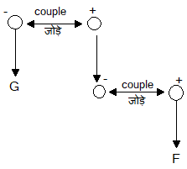

**7:**

Number of triangles present in this following figure?

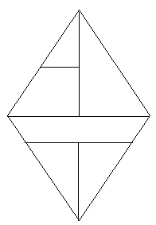

1. 9
2. 6
3. 5
4. 8

**Answer:** option d

**Solution:**

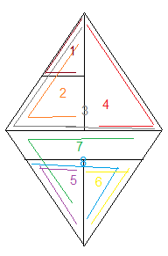

**8:**

A class of 53 students, six students sits between Raman and Raghav; Raman sits at 12th form the beginning. Find Raghav position from the bottom?

1. 35
2. 48
3. 49
4. Cannot be determined

**Answer:** option d

**Solution:**

No statement is given about Raman and Raghav, that who sits before and who is after.

**9:**

Find the Second word according to the dictionary?

1. Judgment
2. Jurisprudential
3. Juncture
4. Judiciary

**Answer:** option d

**Solution:**

1) Judgment

2) Judiciary

3) Juncture

4) Jurisprudential

**10:**

Find the word which cannot be formed using RAMSHACKLE?

1. SHAKE
2. RAM
3. SHE
4. SHAKES

**Answer:** option d

**Solution:**

Only SHAKES cannot be formed using RAMSHACKLE.

**11:**

Which of the two conclusions can be concluded on the basis of given statements?

**Statements**:

Some desk are table.

Some table are chair.

All table is mirror.

Some pen are not chair.

**Conclusion**:

Some pen are desk .

Some chair cannot be a mirror.

1. Conclusion 1 is correct.
2. Either Conclusion 1or 2 is correct.
3. Conclusion 1 and 2 are both wrong.
4. Conclusion 2 is correct.

**Answer:** option c

**Solution:**

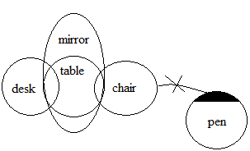

**12:**

Naman moves to 6 km northeast then he moves 9 km to the west and then he moves 6 km to southeast then he moves 3 km to the east. How far he is from his original position?

1. 3
2. 6
3. 17
4. 9

**Answer:** option b

**Solution:**

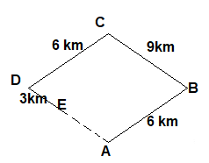

EA = CB = 9 – 3 = 6 km

**13:**

A mirror is put on a line mn, find the correct mirror image for the given diagram?

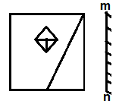

1. 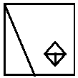
2. 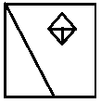
3. 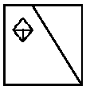
4. 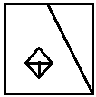

**Answer:** option b

**Solution:**

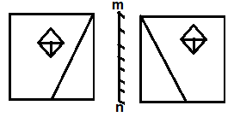

**14:**

In the following question, select the term related to the given options.

Sheep : Flock : : Riders : ?

1. Flock
2. Chorus
3. Cavalcade
4. League

**Answer:** option c

**Solution:**

A group of Sheep is called flock similarly a group of riders is called Cavalcade. So, option (3) is the correct answer.

**15:**

In the question given below, find the missing number from the given options?

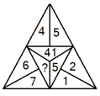

1. 16
2. 9
3. 85
4. 112

**Answer:** option c

**Solution:**

The pattern in the question is

42+52=16+25=41, 22+12=4+1=5

72+62=49+36=85

Hence, option (3) is the correct answer.

**16:**

Read the following information carefully to answer the question that below.

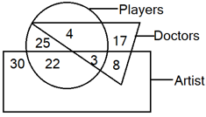

In the above diagram, rectangle represents ‘artists’, circle represents ‘players’ and ‘triangle’ represents ‘doctors’. How many artists are neither doctors nor players?

1. 22
2. 8
3. 25
4. 30

**Answer:** option d

**Solution:**

here are 30 artists who are neither doctors nor players because this is the only region of the rectangle which is not common with either circle or triangle. So, option (D) is the answer.

**17:**

Read the following information carefully to answer the question.

L, M, N, P, Q, R and S are sitting in a circle and playing cards. N, who is the neighbour of P, is

not the neighbor of R.Q is the second to the left of R. N is second to the left of S, who is the neighbor of M. Which of the following is not true?

1. R is to the immediate left to L
2. P is to the immediate right to R
3. N is to the immediate right to P
4. L is to the immediate left to R

**Answer:** option a

**Solution:**

The sitting arrangement of the seven persons is as follows

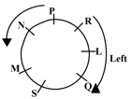

Clearly, R is to the immediate right of L. So, option (1) is not correct.

**18:**

In the following question select the wrong number in the series from the given alternatives.

1447, 1735, 1879, 1951, 1987, 2015, 2014

1. 1879
2. 1951
3. 1987
4. 2015

**Answer:** option d

**Solution:**

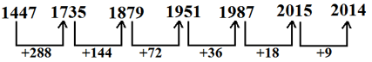

Hence wrong number is 2015

And the correct number that completes series is, 1987+18=2005.

Hence option (4) is correct.

**19:**

In the following question, select the term related to the given options.

KQW : HNT : : PIS : ?

1. MFP
2. QIB
3. ESQ
4. GES

**Answer:** option a

**Solution:**

K – 3 = H

Q – 3 = N

W – 3 = T

Similarly

P – 3 = M

I – 3 = F

S – 3 = P

So, option (1) is the correct answer.

**20:**

In the following question, four alternatives are given, three of which are similar in some way, while

The fourth is different. Choose the odd one.

1. 15 : 63
2. 22 : 91
3. 23 : 95
4. 31 : 97

**Answer:** option d

**Solution:**

In all other pairs, 2nd number = (1st number × 4) + 3

So, option (4) is the correct answer.

**21:**

**Statement**

A ≥ B > C = D

**Conclusion**

1. A > B

2. A = B

1. Only 1 follow
2. Only 2 follow
3. Both will follow
4. Either 1 or 2 will follow

**Answer:** option d

**Solution:**

From statement and conclusion, either conclusion 1 or 2 will follow.

**22:**

In the following question, select odd word from the given alternatives.

1. Pilot
2. Guide
3. Driver
4. License

**Answer:** option d

**Solution:**

Except option (4) all others have same meaning.

**23:**

If LACK = 13, then RANK = ?

1. 12
2. 22.5
3. 26
4. 21.5

**Answer:** option d

**Solution:**

As,

12 1 3 11

L A C K = [(12 + 1 + 3 + 11) – 1] ÷ 2

= 26 ÷ 2 = 13

Similarly,

18 1 14 11

R A N K= [(18 + 1 + 14 + 11) – 1] ÷ 2

= 43 ÷ 2 = 21.5

Hence, ‘RANK’ = 21.5

**24:**

The angle between the minute hand and the hour hand of a clock when the time is 11:30 is:

1. 90°
2. 135°
3. 165°
4. 195°

**Answer:** option b

**Solution:**

trick: angle (θ) = 30*H – $\frac{11}{2}M$

= 30*11 - $\frac{11}{2}30$

= 135°

**25:**

If FRISKED is coded as HTKUMGF, then how will SUN be coded as?

1. UWP
2. RGZ
3. KMJ
4. ZBF

**Answer:** option a

**Solution:**

As,

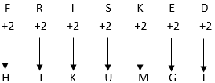

Similarly,

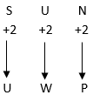

Thus SUN is coded as UWP.